**A**

**Project Report on**

**Masked Face Attendance**

**By**

Karan Dogra, Aparnam Saini, Issha Sethi, Kriti Singh, Rohini Sharma.



**DEPARTMENT**

**OF**

**COMPUTER SCIENCE & ENGINEERING**

Model Institute of Engineering & Technology – Jammu

**A**

**Project Report on**

**Masked Face Attendance**

**In partial fulfillment of requirements for the degree of**

Bachelor of Engineering

In

Computer Science & Engineering

**SUBMITTED BY:**

Karan Dogra, Aparnam Saini, Issha Sethi, Kriti Singh and Rohini Sharma.

**Under the Guidance of**

Prof (Dr) Ankur Gupta (Professor) and Dr Anand Kumar Gupta (Associate Professor)



**DEPARTMENT**

**OF**

**COMPUTER SCIENCE & ENGINEERING**

Model Institute of Engineering & Technology – Jammu

**CERTIFICATE**

Certified that major project work entitled “Masked Face Attendance streams from Camera**…”** is a bonafide work carried out in the 7th semester “Karan Dogra, Aparnam Saini, Issha Sethi, Kriti Singh and Rohini Sharma **”** in partial fulfillment for the award of Bachelor of Technology in Computer Science Engineering from Model Institute of Engineering & Technology during the academic year 2018- 2019.

**Project Guide**

Prof (Dr) Ankur Gupta (Professor)

Mr Rishi Gupta (Assistant Professor)

Mr Purnendu Prabhat (Assistant Professor)

Dr Anand Kumar Gupta (Associate Professor)

**ACKNOWLEDGEMENT**

In the present world of competition there is a race of existence in which those are having will to come forward succeed. Project is like a bridge between theoretical and practical working. We five students of Computer Science and Engineering of 4th year in Model Institute of Engineering and technology are preparing the Major Project name, “Masked Face Attendance” .We worked on the project with all of our efforts. We whole heartedly express our sincere gratitude to Prof (Dr) Ankur Gupta (Professor), Mr Rishi Gupta (Assistant Professor), Mr Purnendu Prabhat (Assistant Professor) and Dr Anand Kumar Gupta (Associate Professor) for their support and guidance for the completion of the Major Project. We are also thankful to all our teachers for explaining on critical aspect of topics related to the project. We would like to thank the entire faculty of all other respective departments for their intimate cooperation throughout the period of project completion.

We would also like to thank the Department of Computer Science and Engineering for their guidance, cooperation and encouragement which helped us in the completion of the project. My thanks and appreciation also goes to my Project mate for helping me during the project.

We are also grateful to my parents and friends for their timely aid without which we wouldn’t have finished our project successfully. We extend our thanks to all our well-wishers and all those who have contributed directly and indirectly for the completion of this work.

We will be failing in duty if we do not acknowledge with grateful thanks to the authors of the references and other literatures referred to in this Project report. Last but not the least; we are very much thankful to my parents who guided me in every step which I took.

**Karan Dogra (1605/17)**

**Aparnam Saini (1627/17)**

**Issha Sethi (1633/17)**

**Kriti Singh (1683/17)**

**Rohini Sharma (2015/LES/18)**

**TABLE OF CONTENTS**

**INDEX | HEADING**

**ABSTRACT**

1. **Introduction**
   1. **Introduction About Computer Vision**
   2. **The Problem it solves**
   3. **Applications and uses of Computer Vision**
   4. **Industrial Application Computer Vision**
2. **Scope**
3. **Technologies And Dependencies** 
   1. **Technology in use**
   2. **Tools used**
   3. **Languages and API**
   4. **Prerequisites and Dependences**
   5. **Pre-Trained Model Used**
4. **Implementation and Methodology**
   1. **Research and Analysis**
   2. **Implementation Method**
5. **Diagrams**
   1. **Uses Cases and Functional Workflow**
   2. **Interaction Model**
   3. **Data Processing Work – Flow**
   4. **Architecture Diagram**
6. **Conclusion**

**BIBLOGRAPHY**

**ABSTRACT**

*In this pandemic, facemasks have proven to be a very effective measure to slow down the spread of the disease and it is recommended by all organizations like World Health Organization, Center of Disease Control, etc to wear them when in public places. As it helps in controlling the spread of Covid 19. So our project i.e. “Masked Face Attendance” aims to complement people’s efforts and help them in making their workplace safer by encouraging the use of Face Mask in public places. Many existing automatic face recognition systems based on facial recognition and other biometric verification methods have failed due multitude of reasons in the pandemic. In context of facial recognition, many existing algorithms and systems have failed to recognize face mainly because these systems and algorithms mainly focuses on facial features such as nose, lips, shapes of face and jaw line for gathering relevant information for face detection and then recognition. Since these facial features are mostly covered by the Face Mask, these systems suffer many issues in both detection as well as recognition of a face.*

*Our project aims to solve this problem by using the uncovered portion (portions which are not covered by the mask which is the upper half of the face) of their faces as to form our data set which is to be used for creating and updating the model the dataset for training the model. Also, we are using a texture based Facial recognition algorithm ie LBPH facial recognition algorithm for the task as it doesn’t focuses on the facial features such as. At the same time our objective is to mark the attendance even if an individual is wearing a face mask or not with no human interference.*

*In our project, the system will take the input in the form of video stream from an ip-camera, with the help of computer vision the mask status and identity of the person in the frame of the camera will deduced. This information is stored in the database along with the date and time of recognition. This project aims to evaluate the attendance of a organization or an institute. This is very important so that an organization can work at peak efficiency, cost reductions, increased productivity as employees are your biggest asset and maintaining accurate information about their working hours, shifts, and leave is essential. In fact, it can make a lot of difference in the way your business operates, not to mention improving their productivity and efficiency.*

**INTRODUTION**

**1.1 INTRODUCTION ABOUT COMPUTER VISION:**

The project “Masked Face Attendance” is based on the technology domain Computer Vision where the data is analyzed with the help of a video stream from the camera. **Computer vision** is the field of Artificial Intelligence that deals with how computers can be made to gain high-level understanding from digital images or videos. From the perspective of engineering, it seeks to automate tasks that the human visual system can do. It is a multidisciplinary field that could broadly be called a subfield of artificial intelligence and machine learning, which may involve the use of specialized methods and make use of general learning algorithms. Computer Vision is the broad parent name for any computations involving visual content – that means images, videos, icons, and anything else with pixels involved. But within this parent idea, there are a few specific tasks that are core building blocks:

* **Object classification**, you train a model on a dataset of specific objects, and the model classifies new objects as belonging to one or more of your training categories. ∙
* O**bject identification**, your model will recognize a specific instance of an object – for example, parsing two faces in an image and tagging one as Tom Cruise and one as Katie Holmes.

A classical application of computer vision is handwriting recognition for digitizing handwritten content (we’ll explore more use cases below). Outside of just recognition, other methods of analysis include:

* **Video** **motion analysis** uses computer vision to estimate the velocity of objects in a video, or the camera itself.
* **Image segmentation**, algorithms partition images into multiple sets of views.
* **Scene reconstruction** creates a 3D model of a scene inputted through images or a video.
* In **image restoration**, noise such as blurring is removed from photos using Machine Learning based filters.

Any other application that involves understanding pixels through software can safely be labeled as computer vision.

**1.2 THE PROBLEM IT SOLVES:**

As humans, we are capable of understanding and describing a scene encapsulated in an image. This involves much more than detecting four people in the foreground, one street, and several cars as in the image below.

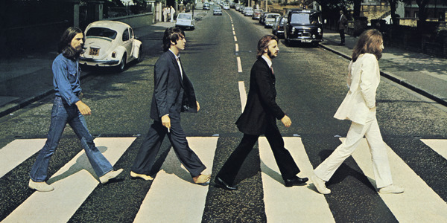

Aside from that basic information, we are able to understand that the people in the foreground are walking, that one of them is barefoot — a curious thing — and we even know who they are. We can reasonably infer that they are not in danger of being hit by a car and that the white Volkswagen is poorly parked. A human would also have no problem describing the clothes they are wearing and, in addition to indicating the color, guessing at the material and texture of each outfit.

These are also the skills a computer vision system needs. In a few words, the main problem solved by computer vision can be summarized as follows:

Given a two-dimensional image, a **computer vision system must recognize the present objects and their characteristics** such as shapes, textures, colors, sizes, spatial arrangement, among other things, to provide a description as complete as possible of the image.

**1.3 APPLICATIONS OF COMPUTER VISION**

Computer vision is based on an extensive set of diverse tasks, combined to achieve highly sophisticated applications. The most frequent tasks in computer vision are image and video recognition, which basically consist of determining the different objects an image contains.

**1.3.1. Image classification**

Probably one of the most well-known tasks in computer vision is **image classification**. It allows for the classification of a given image as belonging to one of a set of predefined categories. Let’s take a simple binary example: we want to categorize images according to whether they contain a tourist attraction or not. Suppose that a classifier is built for this purpose and that the image below is provided.

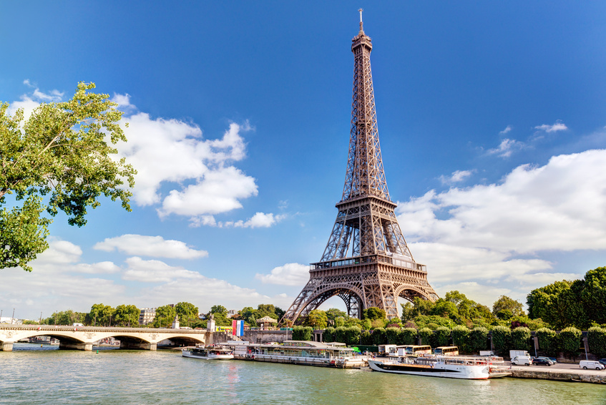

**The Eiffel Tower**

The classifier will respond that the image belongs to the group of images containing tourist attractions. This does not mean that it has necessarily *recognized* the Eiffel Tower but rather that it has *previously seen* photos of the tower and that *it has been told* that those images contain a tourist attraction.

A more ambitious version of the classifier could have more than two categories. For example, there could be a category for each specific type of tourist attraction that we want to recognize: Eiffel Tower, Arc de Triomphe, Sacré-Coeur, etc. In such a scenario, the answers per image input could be multiple, as in the case of the postcard above

**1.3.2. Localization**

Suppose now that we not only want to know which tourist attractions appear in an image, but are also interested in knowing exactly where they are. The goal of **localization** is to find the location of a single object in an image. For example, in the image below, the Eiffel Tower has been *localized*.

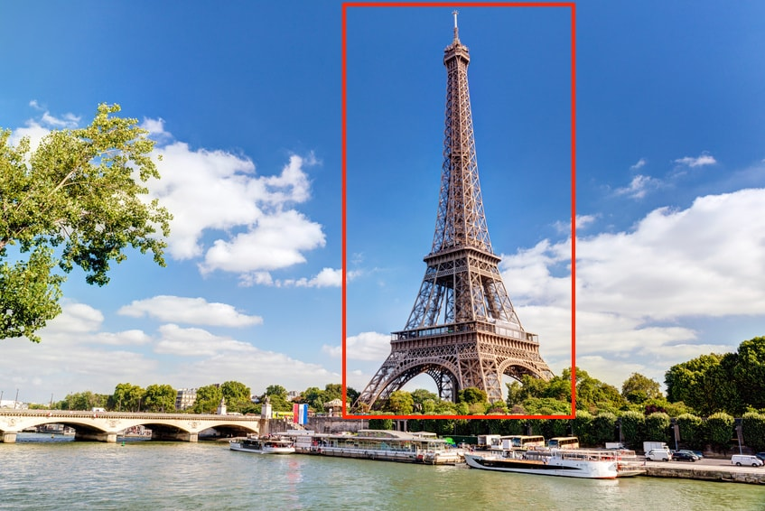

**The Eiffel Tower enclosed by a bounding box**

The standard way to perform localization is to define a bounding box enclosing the object in the image. Localization is a particularly useful task. It can allow for the automatic cropping of objects in a set of images, for instance. If it is combined with the classification task, it could allow us to quickly build a dataset of (cropped) images of famous tourist attractions.

**1.3.3. Object detection**

If we imagine an action involving simultaneous location and classification, repeated for all objects of interest in an image, we end up with [**object detection**](https://tryolabs.com/blog/2017/08/30/object-detection-an-overview-in-the-age-of-deep-learning/). In this case, the number of objects an image can contain is unknown, if it contains any at all. The purpose of object detection is, therefore, to find and then classify a *variable number of objects* in an image.

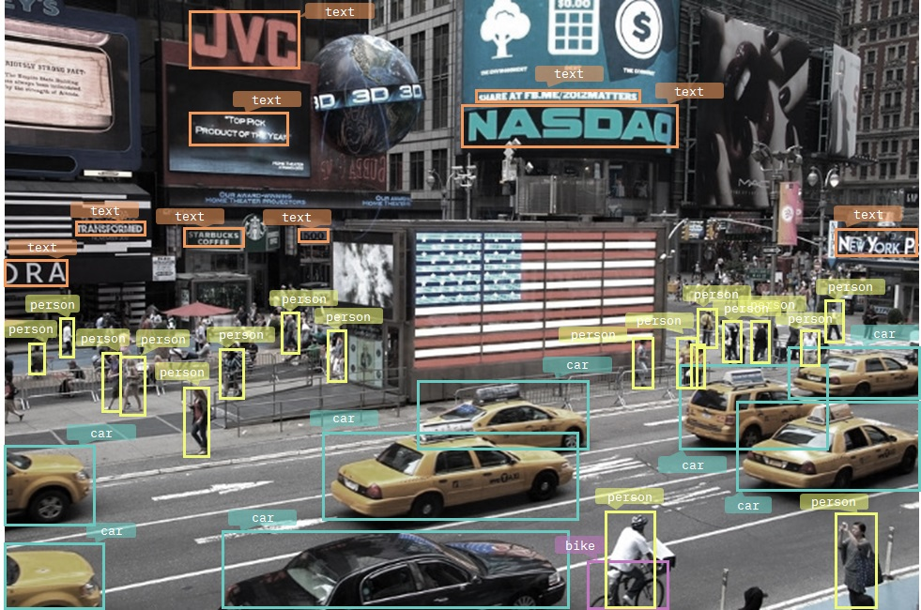

**Object detection results**

In this particularly dense image, we see how a computer vision system identifies a large number of different objects: cars, people, bicycles, and even street signs containing text. The problem would be complex even for a human. Some objects are only partially visible, either because they’re partly outside the frame or because they are overlapping each other. Also, the sizes of similar objects vary greatly. A straightforward application of object detection is **counting**. The applications in real life are quite diverse, from counting different types of fruit harvested to counting people at events such as public demonstrations or football matches.

**1.3.4. Object identification**

**Object identification** is slightly different from object detection, although similar techniques are often used to achieve them both. In this case, *given a specific object*, the goal is to find instances of said object in images. It is not about classifying an image, as we saw previously, but about determining if the object appears in an image or not, and if it does appear, specifying the location(s) where it appears. An example may be searching for images that contain the logo of a specific company. Another example is monitoring real time images from security cameras to identify a specific person’s face.

**Instance segmentation** can be seen as a next step after object detection. In this case, it’s not only about finding objects in an image, but also about creating a mask for each detected object that is as accurate as possible.

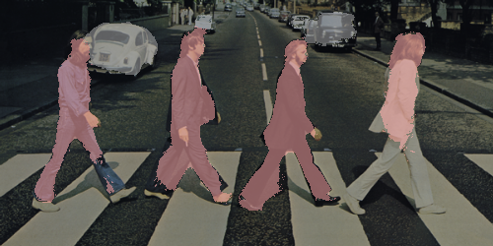

**Instance segmentation results**

You can see in the image above how the instance segmentation algorithm finds masks for the four Beatles and some cars (although the result is incomplete, especially where it comes to Lennon).

**1.3.5. Object tracking**

The purpose of **object tracking** is to track an object that is in motion over time, utilizing consecutive video frames as the input. This functionality is essential for robots that are tasked with everything from pursuing goals to stopping a ball, in the case of goalkeeper robots. It is equally crucial for autonomous vehicles to allow for high-level spatial reasoning and path planning. Similarly, it is useful in various human tracking systems, from those which try to understand customer behavior, as we saw in the case of retail, to those which constantly monitor football or basketball players during a game.

A relatively straightforward way to perform object tracking is to apply object detection to each image in a video sequence and then compare the instances of each object to determine how they moved. The drawback of this approach is that performing object detection for each individual image is typically expensive. An alternative approach would be to capture the object being tracked only once (as a rule, the first time it appears) and then discern the movements of that object without explicitly recognizing it in the following images. Finally, an object tracking method does not necessarily need to be capable of detecting objects; it can simply be based on motion criteria, without being aware that the object is being tracked.

## 1.4. INDUSTRIAL APPLICATION OF COMPUTER VISION

Humans are not only capable of understanding scenes corresponding to images, but also of interpreting handwriting, impressionist or abstract paintings and, with a little training, the 2D ultrasound of a baby .In that sense, the field of computer vision is particularly complex, possessing an immense range of practical applications. The good thing about innovation that relies on artificial Intelligence and machine learning, in general, and computer vision, in particular, is that companies of all types and sizes, from the e-commerce industry to more classic ones, can take advantage of its powerful capabilities.Let’s take a look at some of the industry applications that have been the most impactful in recent years.

### 1.4.1 Retail

The use of computer vision in the retail sector has been one of the most important technological trends in recent years. Below, you’ll be introduced to some very common use cases. If you want a more detailed description of the potential applications in retail, some points are given below:

#### Behavioral tracking

#### Brick and mortar retailers use computer vision algorithms in combination with store cameras to understand who their customers are and how they behave. Algorithms are able to recognize faces and ****determine human characteristics****, such as gender or age range. What’s more, retailers can use computer vision techniques to ****track customers’ movements**** through stores, analyze navigational routes, detect walking patterns, and measure storefront attention times. Adding **directional gaze detection**, retailers are able to answer a crucial question: where to put the items in the store to improve the consumer experience and maximize sales.

Computer vision is also an excellent tool for developing **anti-theft mechanisms**. Among other things, face recognition algorithms can be trained to spot known shoplifters or to detect when someone is hiding an item in their backpack.

#### Inventory management

When it comes to inventory management, there are two main computer vision applications. Through security camera image analysis, a computer vision algorithm can generate a **very accurate estimate of the items available in the store**. This is extremely valuable information for store managers, who can immediately become aware of an unusual increase in demand and react early and efficiently.Another fairly common application is **analyzing the use of shelf space to identify suboptimal configurations**. In addition to discovering lost space, an algorithm of this nature can suggest better item placement.

### 1.4.2 Manufacturing

Major problems that can occur on a manufacturing line are the breaking of machines or the production of defective components. These result in delays and significant losses in profits. Computer vision algorithms prove to be a great means of **predictive maintenance**. By analyzing visual information (e.g. from cameras attached to robots), algorithms can identify potential trouble before it occurs. The fact that a system can anticipate that a packaging or car assembly robot will fail is a huge contribution.

The same idea applies to **defect reduction**, where the system can spot defects in components throughout the entire production line. This allows manufacturers to take action in real time and decide what should be done to resolve the issue. Perhaps the defect is not so serious and the process can continue, but the product is flagged in some way or redirected through a specific production path. Sometimes, however, it may be necessary to stop the production line. Of further interest is that the system can be trained, for each use case, to classify the defects by types and degrees of severity.

### 1.4.3 Healthcare

In the healthcare domain, the number of existing computer vision applications is impressive. Undoubtedly, **medical image analysis** is the best known example, since it helps to significantly improve the medical diagnostic process. Images from MRIs, CT scans, and X-rays are analyzed to find anomalies such as tumors or search for signs of neurological illnesses.In many cases, it’s all about image analysis techniques, which extract features from images in order to train a classifier to be able to detect anomalies. However, there are specific applications where finer processing is required. For example, in the analysis of images from colonoscopies, it is necessary to segment the images to look for polyps and prevent colorectal cancer.

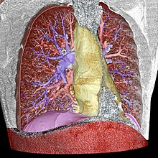

#### Volume segmentation of a 3D-rendered CT scan of the thorax

The image above is a result of image segmentation used to visualize thoracic elements. The system segments and colors each important part: the pulmonary arteries (blue), the pulmonary veins (red), the mediastinum (yellow), and the diaphragm (violet).

A large amount of applications of this type are currently in use, as varied as techniques that estimate the amount of blood lost due to postpartum hemorrhages; quantify coronary artery calcium; and evaluate blood flow in the human body without an MRI.

### 1.4.4 Autonomous vehicles

Have you ever wondered how self-driving cars can “see”? The field of computer vision plays a central role in the domain of autonomous vehicles, since it allows them to perceive and understand the environment around them in order to operate correctly.

One of the most exciting challenges in computer vision is [**object detection**](https://tryolabs.com/blog/2017/08/30/object-detection-an-overview-in-the-age-of-deep-learning/) in images and videos. This involves locating a varying number of objects and the ability to classify them, in order to distinguish if an object is a traffic light, a car, or a person, as in the video below.



#### Object detection for self-driving cars

This kind of technology, combined with the analysis of data from other sources, such as sensors and/or radars, is what allows a car to “see”.

### 1.4.5 Agriculture

Agriculture is a major industry where computer vision is having a tremendous impact, especially in the area of precision agriculture.

In **grain production**, a global economic activity, a series of valuable applications have been developed. Grain production faces certain recurring issues, which historically have been monitored by humans. However, computer vision algorithms can now detect, or in some cases can reasonably predict, diseases or pest and insect infestations. Early diagnosis allows farmers to take appropriate measures quickly, reducing losses and ensuring production quality.

Another permanent challenge is **weed control**, considering that weeds have become resistant to herbicides over time and represent significant losses for farmers. There are robots with integrated computer vision technology that monitor an entire farm and spray herbicides precisely. This saves huge volumes of pesticides, which is an incredible benefit for the planet and in terms of production costs.

**Soil quality** is likewise a major factor in agriculture. There are applications that can recognize, from images taken with mobile phones, potential defects and nutritional deficiencies in soils. After analyzing the images sent, these applications suggest soil restoration techniques and possible solutions to the problems detected.

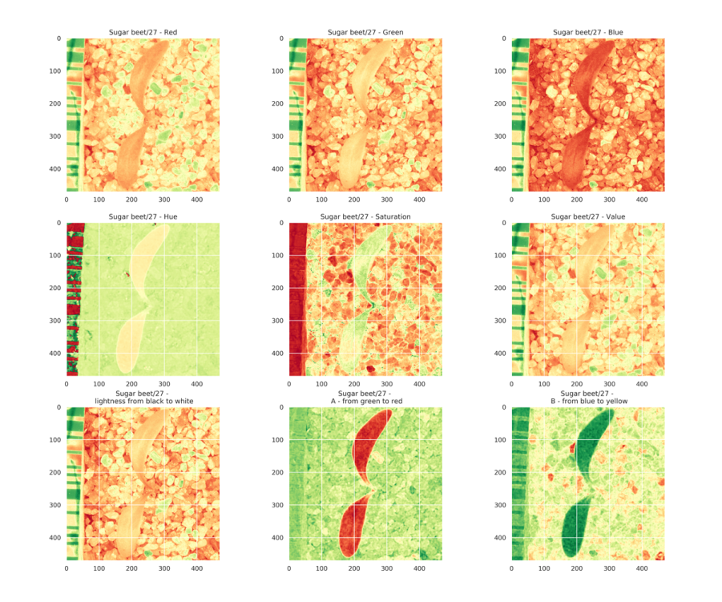

**Heat Maps for Crops**

**SCOPE**

In this pandemic, facemasks have proven to be a very effective measure to slow down the spread of the disease and it is recommended by all organizations like World Health Organization, Center of Disease Control, etc to wear them when in public places. As it helps in controlling the spread of Covid 19. So our project i.e. “Masked Face Attendance” aims to complement people’s efforts and help them in making their workplace safer by encouraging the use of Face Mask in public places. Many existing automatic face recognition systems based on facial recognition and other biometric verification methods have failed due multitude of reasons. In context of facial recognition, many existing algorithms and systems have failed to recognize face mainly because these systems and algorithms mainly focuses on facial features such as nose, lips, shapes of face and jaw line for gathering relevant information for face detection and then recognition. Since these facial features are mostly covered by the Face Mask, these systems suffer many issues in both detection as well as recognition of a face.

To this emergent problem we have proposed a solution, where we use the portions of the face which are not covered by a face mask i.e. the upper half of the mask along with the use of a texture based Facial recognition algorithm ie LBPH facial recognition algorithm for the task as it doesn’t focuses on the facial features such as. At the same time our objective is to mark the attendance even if an individual is wearing a face mask or not with no human interference. Other Biometric methods of marking attendance such as physical attendance and finger print scanning carry high to moderate amounts of risk of spreading the Corona Virus. Also with the help of secondary model running along with recognition model, our project is able to detect whether a person is wearing a face mask or not. This data is also is recorded along with the attendance so that it can be reviewed by the admin.

In our project, the system will take the input in the form of video stream from an ip-camera, with the help of computer vision the mask status and identity of the person in the frame of the camera will deduced. This information is stored in the database along with the date and time of recognition. This project aims to evaluate the attendance of an organization or an institute. This is very important so that an organization can work at peak efficiency, cost reductions, increased productivity as employees are your biggest asset and maintaining accurate information about their working hours, shifts, and leave is essential. In fact, it can make a lot of difference in the way your business operates, not to mention improving their productivity and efficiency.

**TECHNOLOGIES AND DEPENPENCIES**

**3.1 TECHNOLOGY IN USE**

The technology used in my project is Computer Vision which is a sub field of Artificial Intelligence. We have used this technology to process the video feed coming from the camera.

**3.2 TOOLS USED**

The list of tools used during the project include:

* Visual Studio
* Spyder
* Anaconda
* XAMPP

**3.3 LANGUAGES AND API**

We chose Python for our project because our project falls under the technological domain of Computer Vision which is a sub section in Artificial Intelligence. For Artificial Intelligence, Python is a great language to work with as it is easy to use and it has various libraries which help in the development such as Numpy , Opencv, etc. Apart from these libraries Python is user friendly and interpreted which makes it the language I choose to work with.

**3.3.1 PREQUISTES AND DEPENDENCIES**

Python comes with many modules and packages which can be downloaded and used to make thing simpler. Some of the modules we used in this project are given below:

1. Opencv-contrib-python
2. Numpy
3. PaddlePaddle
4. Paddlehub
5. Mysql.connector
6. Datetime

**3.3.2 PRETRAINED MODELS USED:**

In this project, in order to perform face-Mask detection we used a pre-trained model developed by Bydu i.e. PyramidBox-Lite is a lightweight model developed based on Baidu's paper and is a part of paddlehub package.

**IMPLEMENTATION OF THE PROJECT**

**4.1Research and Analysis**

Research is a very important part of development of any project so as to we tackle the problems effectively and efficiently. A project with proper planning and research will not only end faster in terms of time but will also face less frequent issues with the technology that is being used. With the above mentioned points we started our project and its research for it. Initially me the team used some standard face recognition models which did not give us appropriate results. So, we decided to use a texture based facial recognition system with some testing, it fairly good results so we settled with that. During this tests we noticed that we were having issues with the face detection models like Haarcascade and MTCNN, we came to conclusion that since these model were not developed with face-mask in mind that’s why they were giving such issues. So, the next order of business was to find a light-weight, fast yet accurate model for face-detection. Later, we were also testing the face-mask detection model and noticed that we can use this model for face detection as well, as it also gave the coordinates for the face along with face-mask status. Since this model was made with face mask in mind we did not have any issues which we faced during the use of previous models like MTCNN, etc. So we decided to us the Face-mask Detection model for both purposes ie. Face detection and Face-mask detection.

**4.1 Implementation Method:**

**1. Face- Mask Detection:**

First step in our project will be the face detection and checking the status of the Face-Mask with the help of Paddlehub. This is performed using PyramidBox-Lite is a lightweight model developed based on Baidu's paper. The model is based on the backbone network FaceBoxes. This is part of paddlehub module/package. It has a strong response to common problems such as illumination, mask occlusion, expression changes, scale changes and Robustness. This is used to get the coordinates of the faces within the frame obtained by the camera and status of the mask.

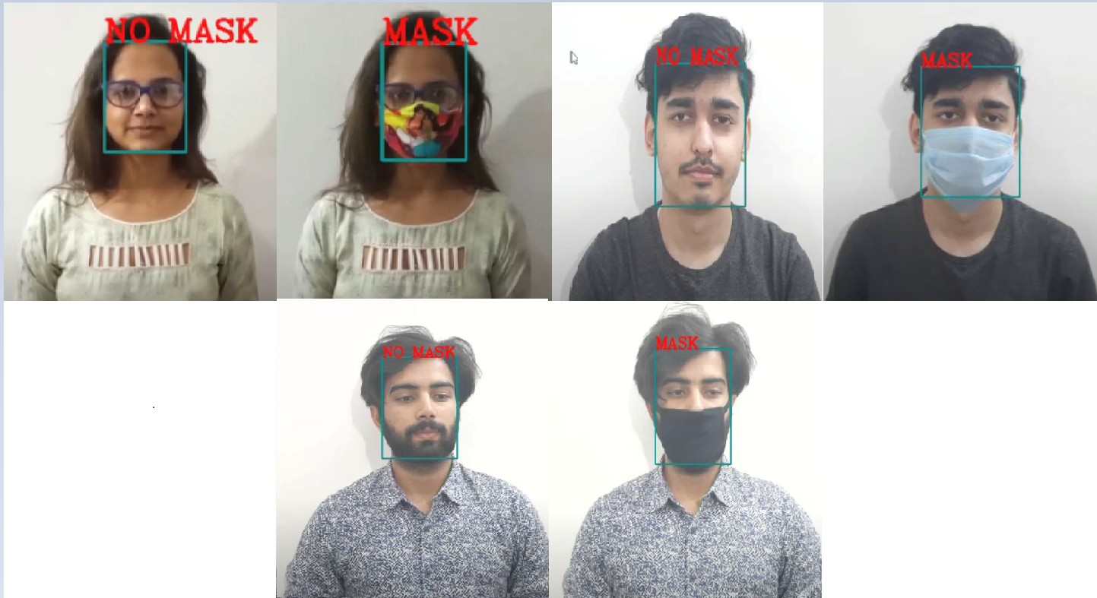

**Face-Mask Detection**

**2. Face Recognition with a face-mask:**

Next step in our project will be the face recognition with the help of texture based face recognition algorithm/technique called LBPH face recognition algorithm. It is widely used in facial recognition due to its computational simplicity and discriminative power. It is best performed on a grayscale image which reduces the processing load and complexity. Continues comparison of adjacent pixels is performed to obtain a texture version of image. For our project only upper half of the face is used as lower part will be covered with a mask. When a person comes in the frame for recognition this process is repeated and two sets of histograms are compared to get suitable result i.e. ID and corresponding confidence.

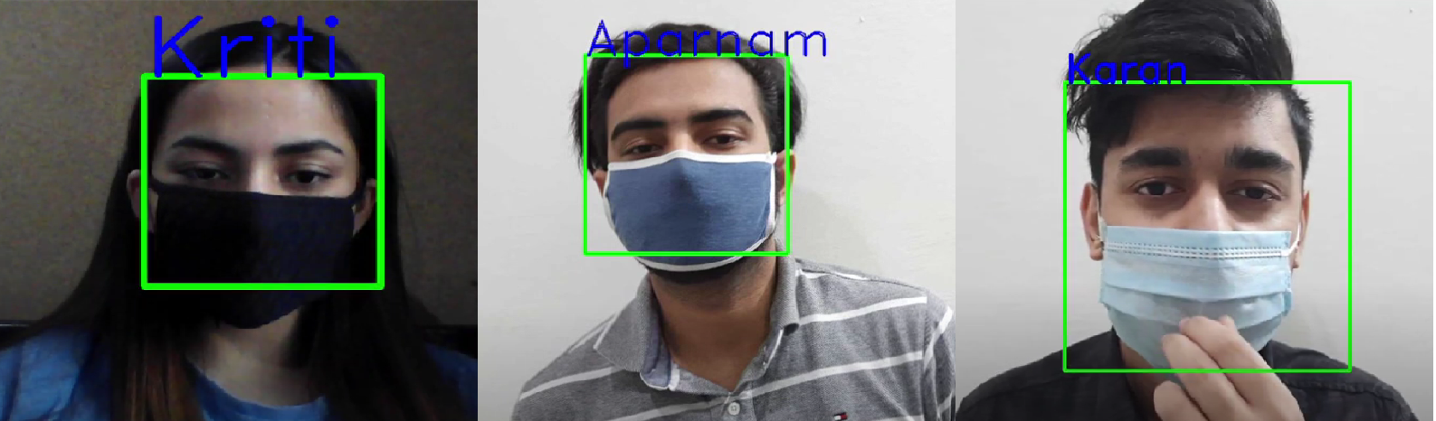

**Face-Mask Detection**

**3. Integration and Attendance Functionality:**

The next step in our project will be using the integrating the previous parts and storing this data produced by the program in the database in order to mark the attendance which is to be displayed in webpage in the future

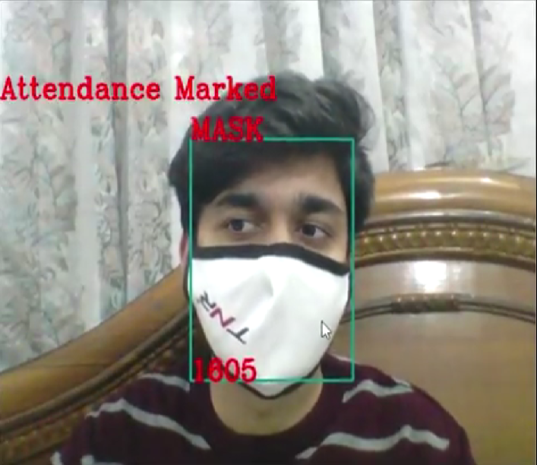

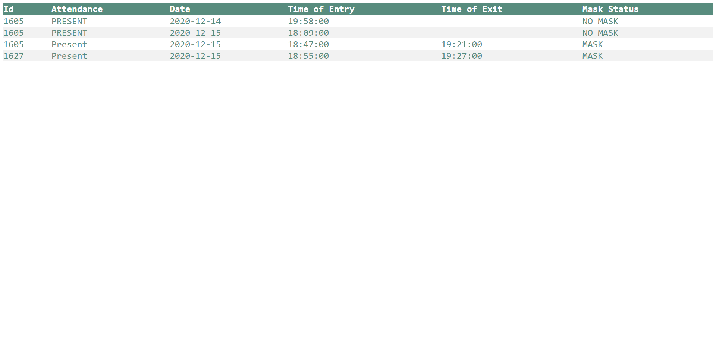 **Face-Mask Detection**

**4. Live Streaming on Webpage with Model Integration:**

The next step in our project in creating a flask application which is able to live stream the IP camera output on a webpage. Once such a web application is developed, this can be integrated with the masked face attendance developed previously. Now we have 2 cameras in such a way:

1. Entry Camera: This is responsible for marking the Entry attendances of the users

2. Exit Camera: This is used to mark the exit times of the user.

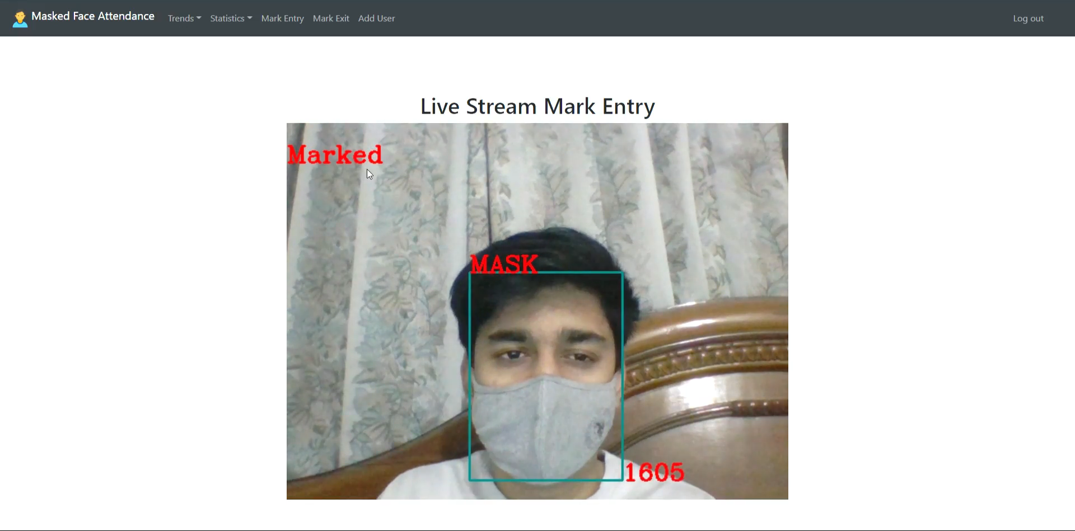 **Live Stream on Webpages**

**5. Website – Tables and Trends:**

The next step in our project using the flask framework to develop a website so the admin and users can access it to mark their attendance as well as see the statistics and trends created from the data in the database.

**Trends:** The trends are made using chart.js framework. The flask code takes the relevant data from the database using SQL query, this is sent to the JavaScript to present the tables

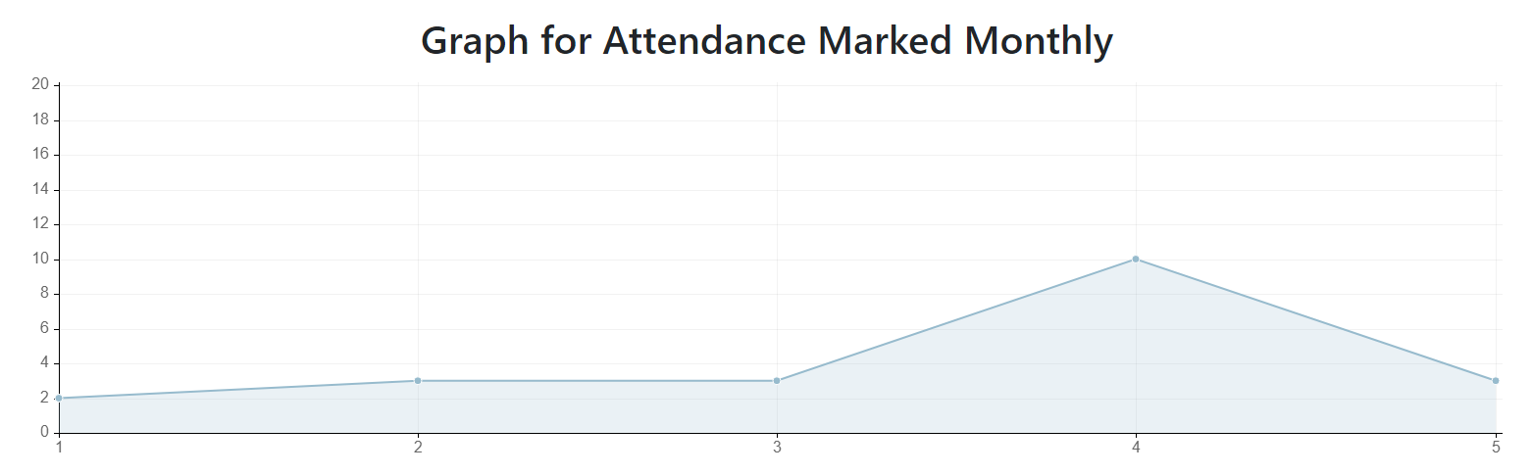 **Trends (Line Graph)**

**Tables:** The tables are made using the bootstrap frontend framework. The flask code takes the relevant data from the database using SQL query, this is sent to the front-end HTML part where, it is presented to the user. It includes List of Users, Attendance Logs, Total Attendance and Mask Violations, Entry and Exit Times and List of Valid Holidays. These tables have a search bar to filter out the cells of the tables, this is also done using JavaScript as well.

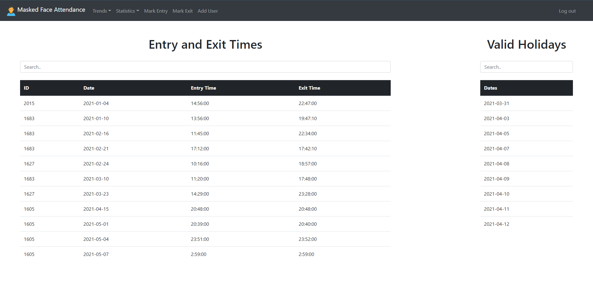 **Statistics (Tables)**

**Adding New User:** Admin can add new users in the database to register them

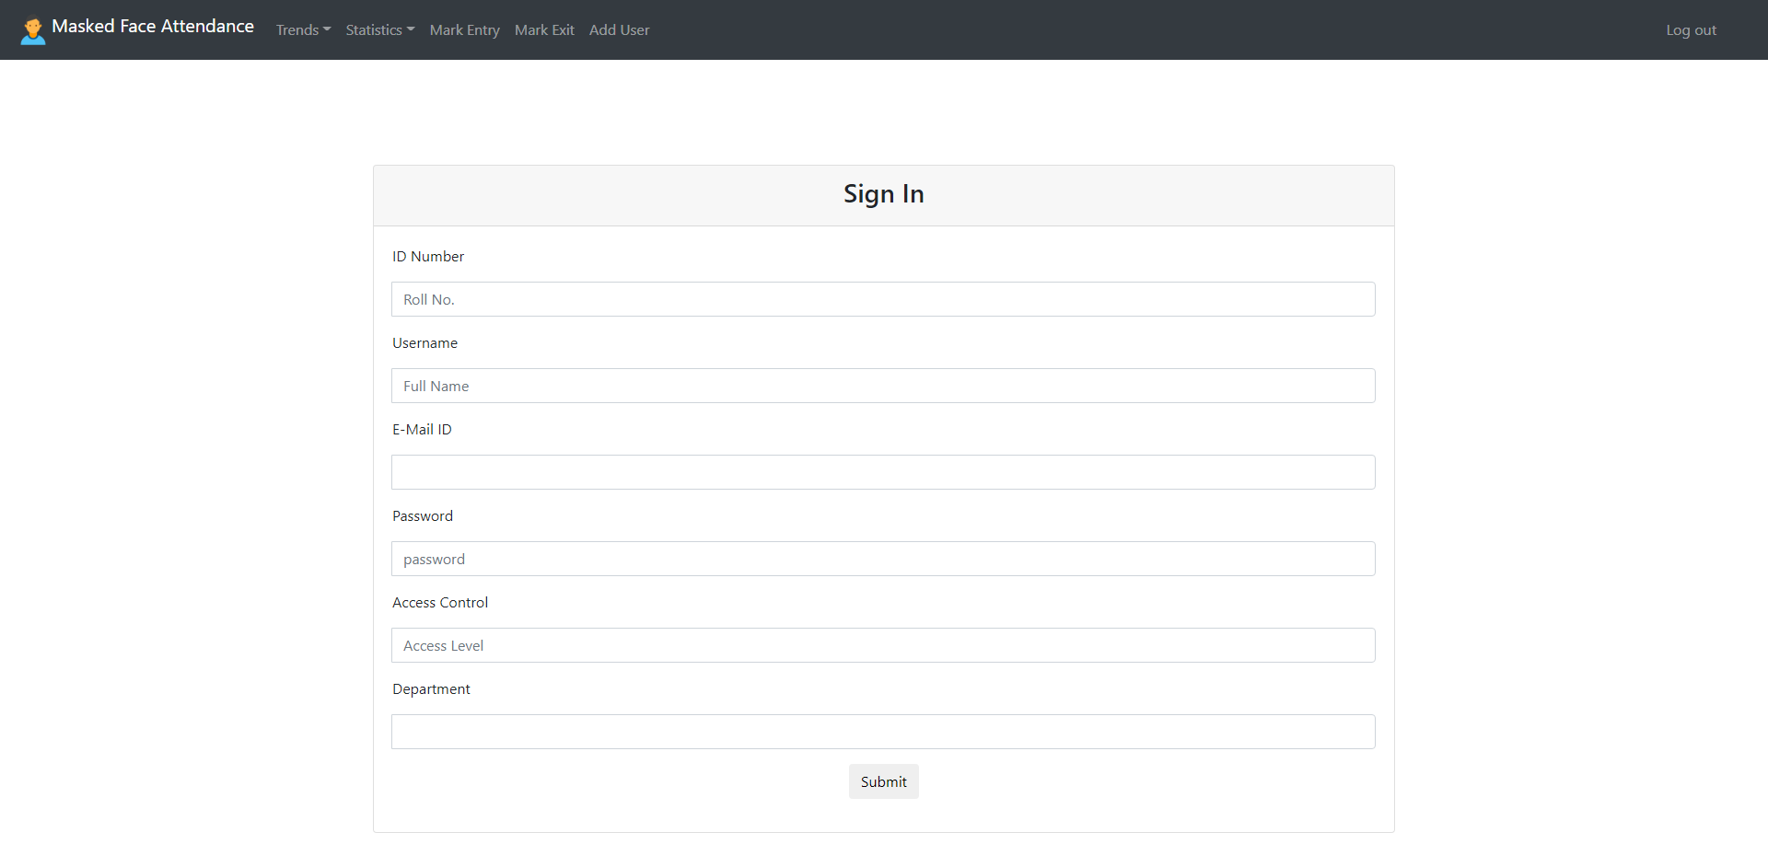 **Add New User Page**

**Diagrams**

**5.1: Use Cases and Functional Workflow:**

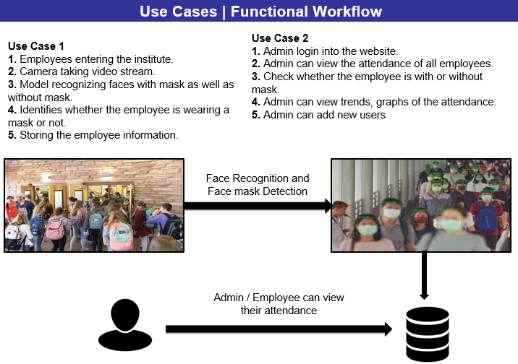

**5.2: Interaction Model:**

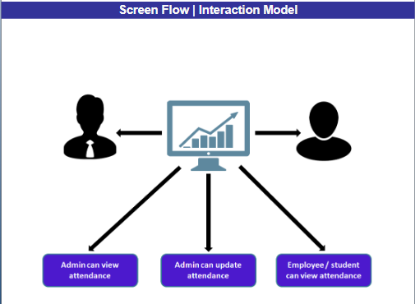

**5.3: Entity Relationship Diagram / Data Processing Workflow:**

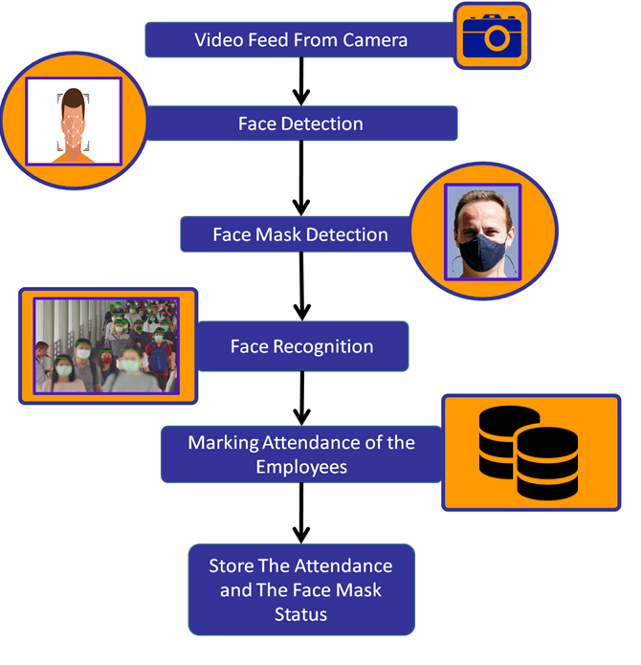

**5.4: Architecture Diagram:**

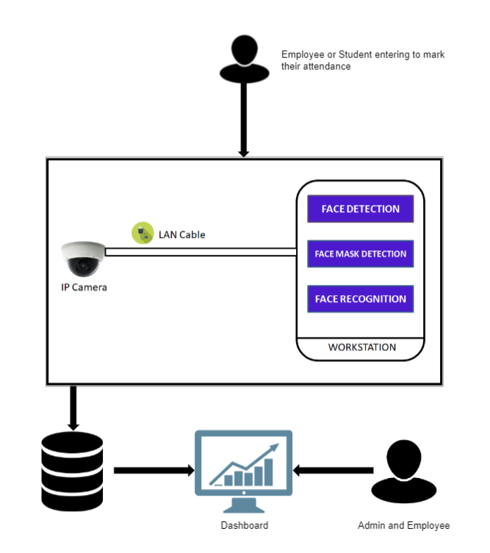

**5.6 Database Design:**

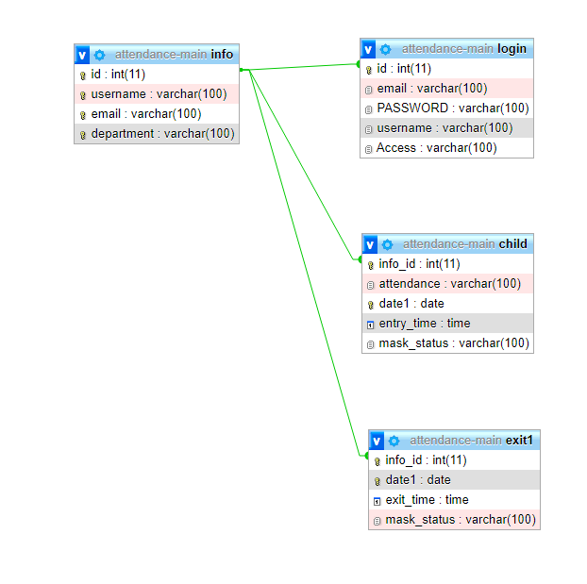

**CONCLUSION**

This project aims to solve the real world issue of marking attendance of the user even if they are wearing a face-mask. This is very important so that an organization can work at peak efficiency, for cost reductions, increased productivity as employees are your biggest asset and maintaining accurate information about their working hours, shifts, and leave is essential. We have proposed a solution which uses computer vision to solve the issue. Face is the representation of one’s identity. Hence, we have proposed an automated student attendance system based on face recognition. Face recognition system is very useful in life applications especially in security control systems.

**BIBLIOGRAPHY**

[1]Kelvin Salton do Prado, “towardsdatascience.com”, <https://towardsdatascience.com/face-recognition-how-lbph-works-90ec258c3d6b>. [Online; Accessed: 2020-9-31].

[2] “Tryo labs”, tryolabs.com, <https://tryolabs.com/resources/introductory-guide-computer-vision/> . [Online; Accessed: 2020-10-02].

[3] “Andrew Ryan”, paddleclas.readthedocs.io, <https://paddleclas.readthedocs.io/en/latest/extension/paddle_hub_en.html>. [Online; Accessed: 2020-10-07].